TASK 3 – Image Selection

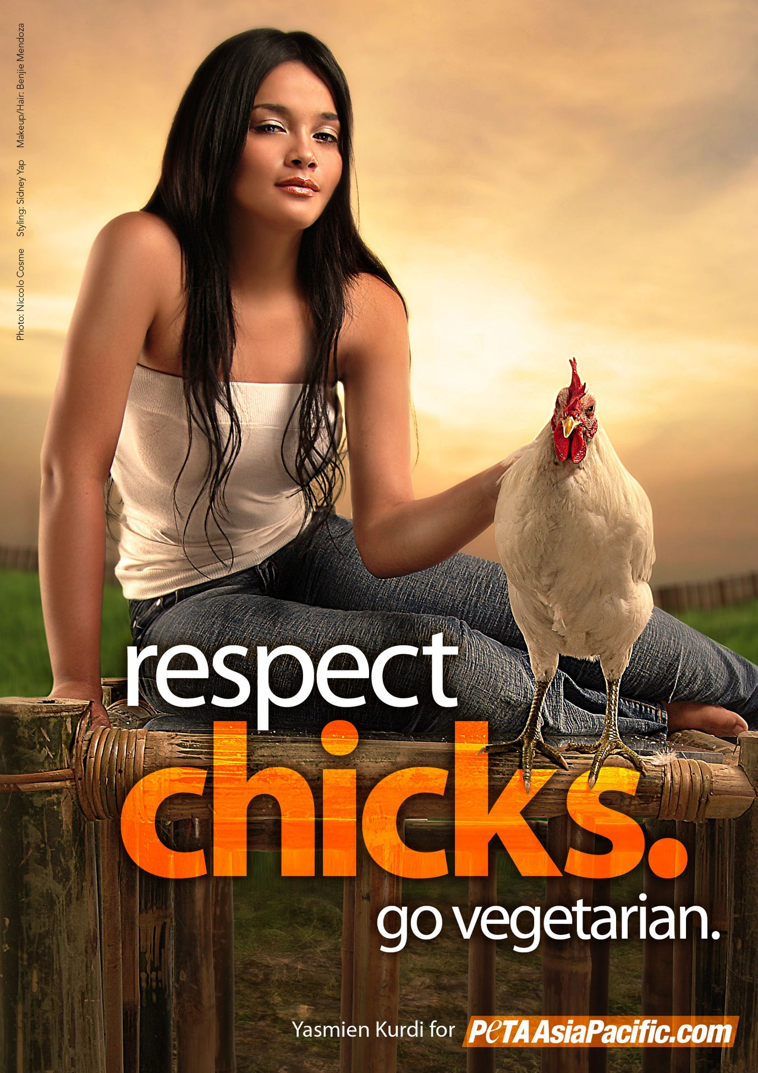

**Title: Peta – Respect Chicks**

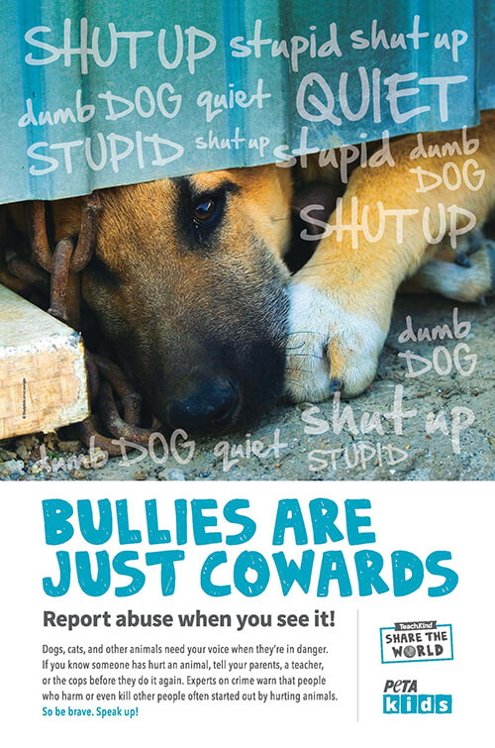

**Title: Peta – Bullies**

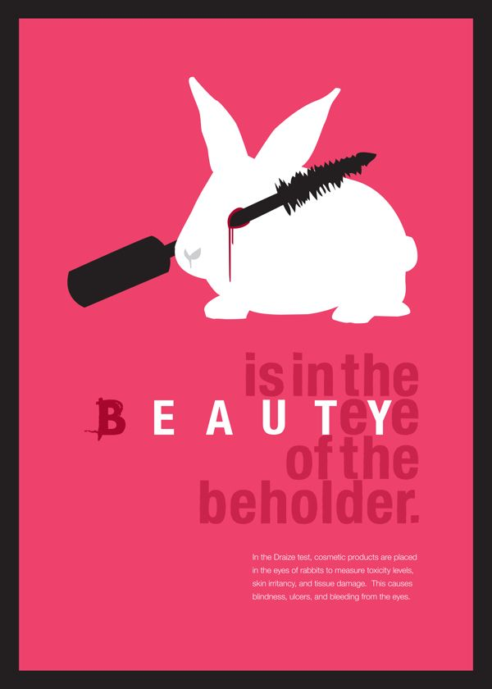

**Title: Beauty**

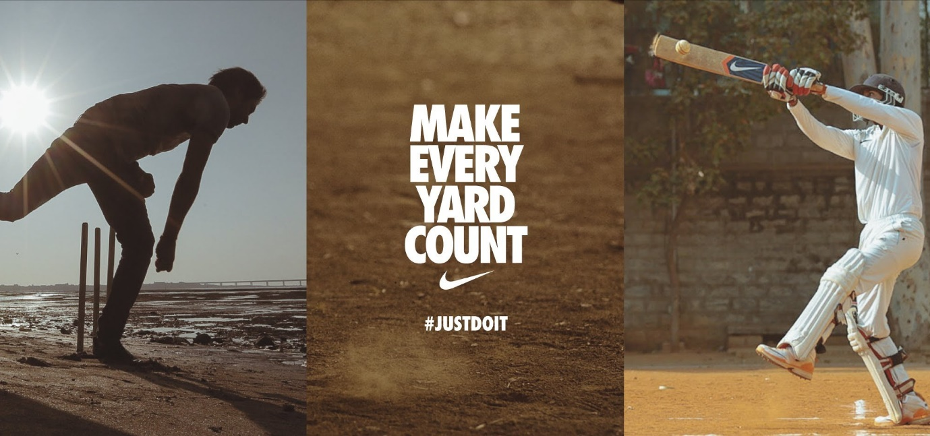

**Title: Nike**